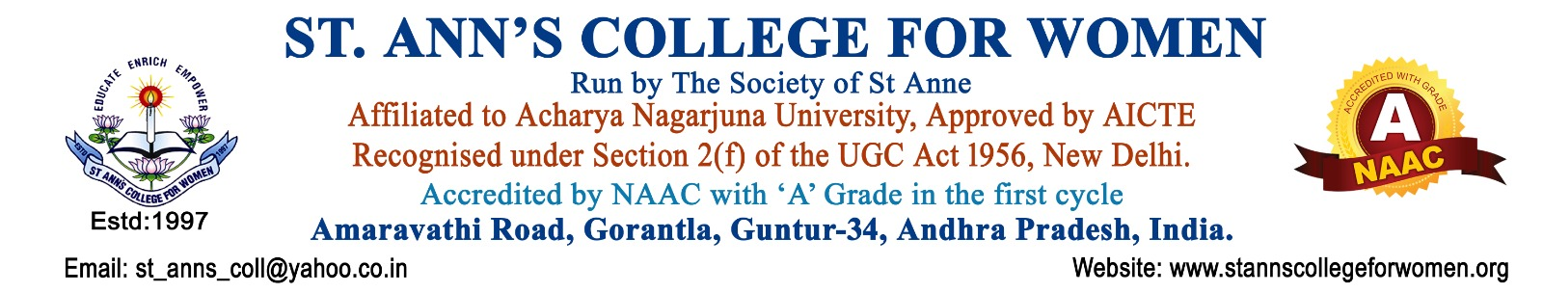

1.EXTENSION, OUTREACH & SOCIAL RESPONSIBILITY POLICY
1. Preamble
The Extension, Outreach & Social Responsibility Policy of the institution is framed to institutionalize community engagement, experiential learning, and social responsibility through structured outreach programmes.
The policy aligns with the guidelines of the University Grants Commission and the quality assurance framework of the National Assessment and Accreditation Council.
As a private unaided affiliated women’s college, the institution is committed to fostering social awareness, women empowerment, environmental sustainability, health consciousness, and inclusive community development, in accordance with affiliating university norms.
2. Objectives
The objectives of this policy are to:
- Promote social responsibility, civic engagement, and ethical citizenship among students and faculty
- Facilitate structured participation in community development and outreach programmes
- Address local, regional, and societal issues through institutional initiatives
- Promote women empowerment, health awareness, environmental sustainability, and digital literacy
- Strengthen collaboration with NGOs, government agencies, and local communities
- Integrate experiential learning with social responsibility and academic engagement
3. Scope
This policy applies to:
- Undergraduate and postgraduate students
- Faculty members and programme coordinators
- Institutional outreach units and statutory clubs
- NSS, NCC, Eco Club, and Red Ribbon Club activities
- Community-based engagement programmes
- Collaborations with external agencies including NGOs and government departments
4. Institutional Framework
4.1 Mother Gnanamma Outreach Committee (MGOC)
The institution shall establish the Mother Gnanamma Outreach Committee (MGOC) as the central coordinating body for planning, implementing, and monitoring all outreach and social responsibility activities.
4.3 Functions of MGOC
The MGOC shall:
- Plan and implement all extension and outreach programmes
- Integrate activities of NSS, NCC, Eco Club, and Red Ribbon Club
- Identify community needs and priority intervention areas
- Organize awareness campaigns on health, environment, and social issues
- Promote student participation in structured outreach programmes
- Coordinate with NGOs, government agencies, and local bodies
- Ensure documentation for NAAC accreditation and institutional reporting
5. Types of Extension Activities
The institution shall undertake the following outreach activities:
- Community Development and Service Programmes
- Health, Hygiene, Nutrition & HIV/AIDS Awareness (Red Ribbon Club activities)
- Environmental Conservation Activities (Eco Club initiatives)
- National Service Scheme (NSS) Social Service Programmes
- NCC Discipline, Leadership & Civic Responsibility Activities
- Literacy and Educational Support Programmes
- Women Empowerment and Legal Awareness Programmes
- Digital Literacy and Skill Development Programmes
- Rural and Urban Community Engagement Initiatives

6. Community Engagement Framework
- Adoption of nearby villages/communities for sustained engagement
- Regular field visits and structured outreach programmes
- Collaboration with local government bodies, NGOs, health departments, and civic agencies
- Identification of community needs through surveys and interaction
- Implementation of need-based social intervention programmes
- Continuous engagement for measurable social impact
7. Roles and Responsibilities
7.1 Principal
- Overall supervision and approval of outreach and extension activities
7.2 Mother Gnanamma Outreach Committee (MGOC)
- Planning, coordination, integration, and monitoring of all outreach programmes
7.3 Programme Officers (NSS/NCC/Eco/RRC)
- Execute unit-specific outreach programmes
- Ensure student participation and reporting
7.4 Faculty Members
- Guide students and support documentation and reporting
7.5 IQAC
- Ensure quality assurance and NAAC compliance
- Maintain institutional evidence and records
8. Student Participation and Learning Outcomes
- Active participation in structured social service programmes
- Development of leadership, empathy, discipline, and civic responsibility
- Exposure to real-life community challenges
- Strengthening of ethical values and social sensitivity
- Enhanced experiential and value-based learning outcomes
9. Collaboration and Partnerships
The institution shall collaborate with:
- Government departments (health, education, rural development)
- NGOs and social service organizations
- Local self-government institutions and community bodies
- Environmental, health, and welfare agencies
- National service organizations linked to NSS/NCC/RRC/Eco initiatives
10. Documentation and Reporting
The institution shall maintain:
- MGOC and club-wise meeting minutes and annual reports
- NSS/NCC/Eco Club/Red Ribbon Club activity reports
- Programme reports with photographs, attendance, and outcomes
- Annual Extension & Outreach Report
- Feedback from beneficiaries and stakeholders
- MoUs and collaboration records (if applicable)
11. Monitoring and Review
- Annual review of all outreach programmes by MGOC
- Consolidated Annual Extension Report submission to IQAC and Governing Body
- Policy review every three years or as per regulatory updates
12. Expected Outcomes
- Strong institutional-community linkage and social visibility
- Increased student participation in structured social responsibility programmes
- Enhanced awareness on health, environment, and social issues
- Contribution to sustainable local development and women empowerment

